The Evolution of Database System
FILE SYSTEM: 1968 File-Based: predecessor of database, Data was maintained in a flat file.
Flat Files: Earlier, punched cards technology was used to store data – later, files. But the files have no as such advantage, rather have several limitations. The file management system also called as FMS in short is one in which all data is stored on a single large file. The data were stored and processed using traditional file processing systems. In these traditional file systems, each file is independent of other file, and data in different files can be integrated only by writing individual program for each application. The data and the application programs that uses the data are so arranged that any change to the data requires modifying all the programs that uses the data. This is because each file is hard-coded with specific information like data type, data size etc. Some time it is even not possible to identify all the programs using that data and is identified on a trial-and-error basis.
The main disadvantage in this system is searching a record or data takes a long time. This lead to the introduction of the concept, of indexing in this system. Then also the FMS system had lot of drawbacks to name a few like updating or modifications to the data cannot be handled easily, sorting the records took long time and so on. All these drawbacks led to the introduction of the Hierarchical Database System.
A file processing system of an organization is shown in figure below. All functional areas in the organization create processes and disseminate its own files. The files such as inventory and payroll generate separate files and do not communicate with each other.
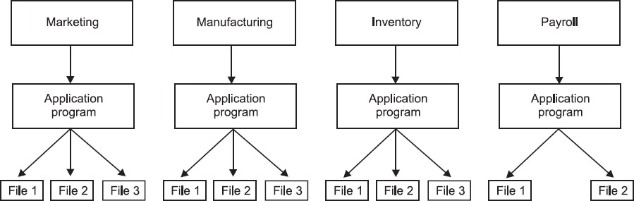
Disadvantages of Traditional File System

1) Data Redundancy: Since each application has its own data file, the same data may have to be recorded and stored in many files. For example, personal file and payroll file, both contain data on employee name, designation etc. The result is unnecessary duplicate or redundant data items. This redundancy requires additional or higher storage space, costs extra time and money, and requires additional efforts to keep all files upto-date.
2) Data Inconsistency: Data redundancy leads to data inconsistency especially when data is to be updated. Data inconsistency occurs due to the same data items that appear in more than one file do not get updated simultaneously in each and every file. For example, an employee is promoted from Clerk to Superintendent and the same is immediately updated in the payroll file may not necessarily be updated in provident fund file. This results in two different designations of an employee at the same time. Over the period of time, such discrepancies degrade the quality of information contain in the data file that affects the accuracy of reports.
3) Lack of Data Integration: Since independent data file exists, users face difficulty in getting information on any ad hoc query that requires accessing the data stored in many files. In such a case complicated programs have to be developed to retrieve data from every file or the users have to manually collect the required information.
4) Program Dependence: The reports produced by the file processing system are program dependent, which means if any change in the format or structure of data and records in the file is to be made, the programs have to modify correspondingly. Also, a new program will have to be developed to produce a new report.
5) Data Dependence: The Applications/programs in file processing system are data dependent i.e., the file organization, its physical location and retrieval from the storage media are dictated by the requirements of the particular application. For example, in payroll application, the file may be organized on employee records sorted on their last name, which implies that accessing of any employee's record has to be through the last name only.
6) Limited Data Sharing: There is limited data sharing possibilities with the traditional file system. Each application has its own private files and users have little choice to share the data outside their own applications. Complex programs required to be written to obtain data from several incompatible files.
7) Poor Data Control: There was no centralized control at the data element level; hence a traditional file system is decentralized in nature. It could be possible that the data field may have multiple names defined by the different departments of an organization and depending on the file it was in. This situation leads to different meaning of a data field in different context or same meaning for different fields. This causes poor data control.
8) Problem of Security: It is very difficult to enforce security checks and access rights in a traditional file system, since application programs are added in an adhoc manner.
9) Data Manipulation Capability is Inadequate: The data manipulation capability is very limited in traditional file systems since they do not provide strong relationships between data in different files.
10) Needs Excessive Programming: An excessive programming effort was needed to develop a new application program due to very high interdependence between program and data in a file system. Each new application requires that the developers start from the scratch by designing new file formats and descriptions and then write the file access logic for each new file.

Hierarchical Data Model: [1968-1980] Era of Hierarchical Database: Mid 1960s Rockwell collaborates with IBM to create the Information Management System (IMS), IMS lead the mainframe database market in 70’s and early 80’s. The hierarchical data model organizes data in a tree structure. There is a hierarchy of parent and child data segments. This structure implies that a record can have repeating information, generally in the child data segments. Data in a series of records, which have a set of field values attached to it. It collects all the instances of a specific record together as a record type. These record types are the equivalent of tables in the relational model, and with the individual records being the equivalent of rows. To create links between these record types, the hierarchical model uses Parent Child Relationships. These are a 1:N mapping between record types. This is done by using trees. This restricts a child segment to having only one parent segment.
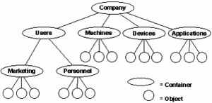
Advantages | Limitations
Efficient searching. | Complex implementation
Less redundant data. | Difficult to manage and lack of standards, can’t easily handle many-many relationships.
Data independence. | Lacks structural independence.
Database security and integrity.

Network Model
The popularity of the network data model coincided with the popularity of the hierarchical data model. Some data were more naturally modeled with more than one parent per child. So, the network model permitted the modeling of many-to-many relationships in data. In 1971, the Conference on Data Systems Languages (CODASYL) formally defined the network model. The basic data modeling construct in the network model is the set construct. A set consists of an owner record type, a set name, and a member record type. A member record type can have that role in more than one set, hence the multiparent concept is supported. An owner record type can also be a member or owner in another set.The complete network of relationships is represented by several pairwise sets; in each set some (one) record type is owner (at the tail of the network arrow) and one or more record types are members (at the head of the relationship arrow). Usually, a set defines a 1:M relationship, although 1:1 is permitted. The CODASYL network model is based on mathematical set theory.
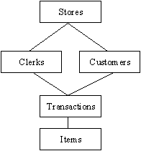

Advantages | Limitations
Ability to handle more relationship types | System complexity and difficult to design and maintain
Ease of data access | Lack of structural independence as data access method is navigational.
Data Integrity
Data Independence

Relational Model
(RDBMS - relational database management system) A database based on the relational model developed by E.F. Codd. A relational database allows the definition of data structures, storage and retrieval operations and integrity constraints. In such a database the data and relations between them are organized in tables. A table is a collection of records and each record in a table contains the same fields. Properties of Relation
• Values Are Atomic
• Each Row is Unique
• Column Values Are of the Same Kind
• The Sequence of Columns is Insignificant
• The Sequence of Rows is Insignificant
• Each Column Has a Unique Name
Certain fields may be designated as keys, which means that searches for specific values of that field will use indexing to speed them up. Where fields in two different tables take values from the same set, a join operation can be performed to select related records in the two tables by matching values in those fields. Often, but not always, the fields will have the same name in both tables. For example, an "orders" table might contain (customer-ID, product-code) pairs and a "products" table might contain (product-code, price) pairs so to calculate a given customer's bill you would sum the prices of all products ordered by that customer by joining on the product-code fields of the two tables. This can be extended to joining multiple tables on multiple fields. Because these relationships are only specified at retrieval time, relational databases are classed as dynamic database management system. The RELATIONAL database model is based on the Relational Algebra.

Object-Oriented Model: Object DBMSs add database functionality to object programming languages. They bring much more than persistent storage of programming language objects. Object DBMSs extend the semantics of the C++, Smalltalk and Java object programming languages to provide full-featured database programming capability. A major benefit of this approach is the unification of the application and database development into a seamless data model and language environment. As a result, applications require less code, use more natural data modeling, and code bases are easier to maintain.
In contrast to a relational DBMS where a complex data structure must be flattened out to fit into tables or joined together from those tables to form the in-memory structure, object DBMSs have no performance overhead to store or retrieve a web or hierarchy of interrelated objects. This one-to-one mapping of object programming language objects to database objects has two benefits over other storage approaches: it provides higher performance management of objects, and it enables better management of the complex interrelationships between objects. This makes object DBMSs better suited to support applications such as financial portfolio risk analysis systems, telecommunications service applications, world wide web document structures, design and manufacturing systems, and hospital patient record systems, which have complex relationships between data.
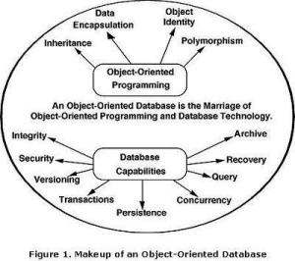

Advantages | Limitations
Can efficiently manage a large number of different data types. | Switching an existing database to OODBMS requires an entire change from scratch.
Objects with complex behaviors are easy to handle using inheritance and polymorphism etc. | An OODBMS is typically tied to a specific programming language and an API; this reduces its flexibility.
Reduces the large number of relations by creating objects. | Ad-hoc queries are difficult to implement as one cannot join two classes as one can join two tables in RDBMS. Therefore, queries depend upon the design of the system.
 | Creates problems when deleting data in bulk.

Database Systems or Database System Environment
The DBMS software together with the Database is called a database system. In other words, it can be defined as an organization of components that define and regulate the collection, storage, management and use of data in a database. Furthermore, it is a system whose overall purpose is to record and maintain information. A database system consists of four major components:
Data: The whole data in the system is stored in a single database. This data in the database are both shared and integrated. Sharing of data means individual pieces of data in the database is shared among different users and every user can access the same piece of data but may be for different purposes. Integration of data means the database can be function of several distinct files with redundancy controlled among the files.
Hardware: The hardware consists of the secondary storage devices like disks, drums and so on, where the database resides together with other devices. There is two types of hardware. The first one, i.e., processor and main memory that supports in running the DBMS. The second one is the secondary storage devices, i.e., hard disk, magnetic disk etc., that are used to hold the stored data.
Software: A layer or interface of software exists between the physical database and the users. This layer is called the DBMS. All requests from the users to access the database are handled by the DBMS. Thus, the DBMS shields the database users from hardware details. Furthermore, the DBMS provides the other facilities like accessing and updating the data in the files and adding and deleting files itself.
Users: The users are the people interacting with the database system in any way. There are four types of users interacting with the database systems. These are Application Programmers, online users, end users or naive users and finally the Database Administrator (DBA).
Advantages of Database Systems (DBMS's)

1) Controlled redundancy: In a traditional file system, each application program has its own data, which causes duplication of common data items in more than one file. This duplication/redundancy requires multiple updations for a single transaction and wastes a lot of storage space. We cannot eliminate all redundancy due to technical reasons. But in a database, this duplication can be carefully controlled, that means the database system is aware of the redundancy and it assumes the responsibility for propagating updates.
2) Data consistency: The problem of updating multiple files in traditional file system leads to inaccurate data as different files may contain different information of the same data item at a given point of time. This causes incorrect or contradictory information to its users. In database systems, this problem of inconsistent data is automatically solved by controlling the redundancy.
3) Program data independence: The traditional file systems are generally data dependent, which implies that the data organization and access strategies are dictated by the needs of the specific application and the application programs are developed accordingly. However, the database systems provide an independence between the file system and application program, that allows for changes at one level of the data without affecting others. This property of database systems allow to change data without changing the application programs that process the data.
4) Sharing of data: In database systems, the data is centrally controlled and can be shared by all authorized users. The sharing of data means not only the existing applications programs can also share the data in the database but new application programs can be developed to operate on the existing data. Furthermore, the requirements of the new application programs may be satisfied without creating any new file.
5) Enforcement of standards: In database systems, data being stored at one central place, standards can easily be enforced by the DBA. This ensures standardised data formats to facilitate data transfers between systems. Applicable standards might include any or all of the following—departmental, installation, organizational, industry, corporate, national or international.
6) Improved data integrity: Data integrity means that the data contained in the database is both accurate and consistent. The centralized control property allow adequate checks can be incorporated to provide data integrity. One integrity check that should be incorporated in the database is to ensure that if there is a reference to certain object, that object must exist.
7) Improved security: Database security means protecting the data contained in the database from unauthorised users. The DBA ensures that proper access procedures are followed, including proper authentical schemes for access to the DBMS and additional checks before permitting access to sensitive data. The level of security could be different for various types of data and operations.
8) Data access is efficient: The database system utilizes different sophisticated techniques to access the stored data very efficiently.
9) Conflicting requirements can be balanced: The DBA resolves the conflicting requirements of various users and applications by knowing the overall requirements of the organization. The DBA can structure the system to provide an overall service that is best for the organization.
10) Improved backup and recovery facility: Through its backup and recovery subsystem, the database system provides the facilities for recovering from hardware or software failures. The recovery subsystem of the database system ensures that the database is restored to the state it was in before the program started executing, in case of system crash.
11) Minimal program maintenance: In a traditional file system, the application programs with the description of data and the logic for accessing the data are built individually. Thus, changes to the data formats or access methods results in the need to modify the application programs. Therefore, high maintenance effort are required. These are reduced to minimal in database systems due to independence of data and application programs.
12) Concurrency control: The database systems are designed to manage simultaneous (concurrent) access of the database by many users. They also prevents any loss of information or loss of integrity due to these concurrent accesses.
13) Economical to scale: In database systems, the operational data of an organization is stored in a central database. The application programs that work on this data can be built with very less cost as compared to traditional file system. This reduces overall costs of operation and management of the database that leads to an economical scaling.

Disadvantages of Database Systems
In contrast to many advantages of the database systems, there are some disadvantages as well.

1) Complexity increases: The data structure may become more complex because of the centralised database supporting many applications in an organization. This may lead to difficulties in its management and may require professionals for management.
2) Requirement of more disk space: The wide functionality and more complexity increase the size of DBMS. Thus, it requires much more space to store and run than the traditional file system.
3) Additional cost of hardware: The cost of database system's installation is much more. It depends on environment and functionality, size of the hardware and maintenance costs of hardware.
4) Cost of conversion: The cost of conversion from old file-system to new database system is very high. In some cases the cost of conversion is so high that the cost of DBMS and extra hardware becomes insignificant. It also includes the cost of training manpower and hiring the specialized manpower to convert and run the system.
5) Need of additional and specialized manpower: Any organization having database systems, need to be hire and train its manpower on regular basis to design and implement databases and to provide database administration services.
6) Need for backup and recovery: For a database system to be accurate and available all times, a procedure is required to be developed and used for providing backup copies to all its users when damage occurs.
7) More installational and management cost: The big and complete database systems are more costly. They require trained manpower to operate the system and has additional annual maintenance and support costs.

Database Design:

Database design is the process of producing a detailed data model of a database. This logical data model contains all the needed logical and physical design choices and physical storage parameters needed to generate a design in a Data Definition Language, which can then be used to create a database. A fully attributed data model contains detailed attributes for each entity.
The term database design can be used to describe many different parts of the design of an overall database system. it can be thought of as the logical design of the base data structures used to store the data. In the relational model these are the tables and views. In an object database the entities and relationships map directly to object classes and named relationships. However, the term database design could also be used to apply to the overall process of designing, not just the base data structures, but also the forms and queries used as part of the overall database application within the database management system (DBMS).
The process of doing database design generally consists of a number of steps which will be carried out by the database designer. Usually, the designer must:
- Determine the relationships between the different data elements.
- Superimpose a logical structure upon the data on the basis of these relationships

DBMS architecture: An early proposal for a standard terminology and general architecture database a system was produced in 1971 by the DBTG (Data Base Task Group) appointed by the Conference on data Systems and Languages. The DBTG recognized the need for a two level approach with a system view called the schema and user view called subschema. The American National Standard Institute terminology and architecture in 1975.ANSI-SPARC recognized the need for a three level approach with a system catalog.

There are following three levels or layers of DBMS architecture:
1. External Level: - External Level is described by a schema i.e. it consists of definition of logical records and relationship in the external view. It also contains the method of deriving the objects in the external view from the objects in the conceptual view. this is a highest level of abstraction as seen by user. This level of abstraction describes only the part of entry database. It is based on the conceptual model, is the end user view of data environment. Each external view described by means of a schema called an external schema or subschema. The external schema consists of the definition of the logical records and the relationships in the external view. The external schema also contains he method of deriving the objects in the external view from the objects in the conceptual view. The object includes entities, attributes and relationships.
2. Conceptual Level: - Conceptual Level represents the entire database. Conceptual schema describes the records and relationship included in the Conceptual view. It also contains the method of deriving the objects in the conceptual view from the objects in the internal view. at this level of database abstraction all the database entities and the relationships among them are included. One conceptual view represents the entire database. the conceptual schema defines ths conceptual view. It there is only one conceptual schema per database. This schema also contains the method deriving from the objects in the conceptual view from the objects in the internal view.. at this level a database is described logically rather then physically in term of data structure.
3. Internal(physical)Level: - Internal level indicates hoe the data will be stored and described the data structures and access method to be used by the database. It contains the definition of stored record and method of representing the data fields and access aid used. this lowest level of abstraction. it closest to physical storage device. It describes how data are actually stored on the storage medium. The internal schema, which contains the definition of the stored record, the method representing the data fields, expresses the internal view and the access aids used.

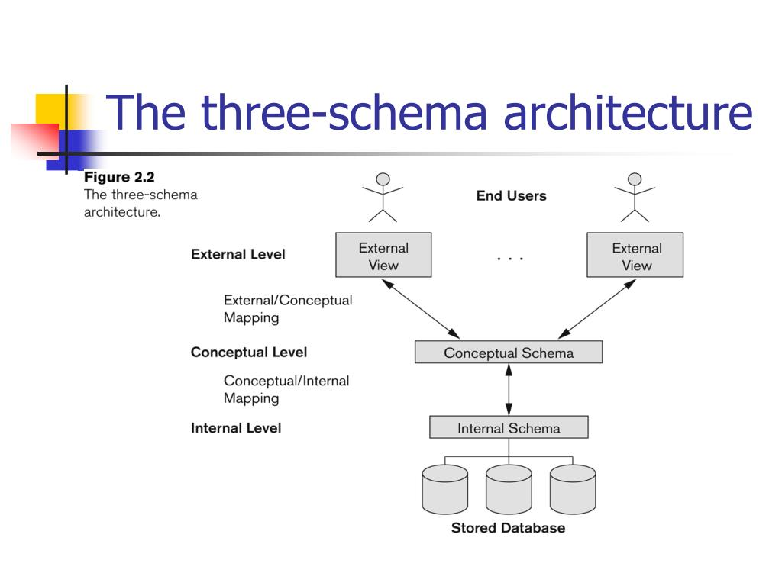
Consider an Example of a University Database. At the different levels this is how the implementation will look like:
Type of Schema | Implementation
External Schema | View 1: Course info(cid:int,cname:string)  View 2: studeninfo(id:int. name:string)
Conceptual Shema | Students(id: int, name: string, login: string, age: integer)  Courses(id: int, cname.string, credits:integer)  Enrolled(id: int, grade:string)
Physical Schema | - Relations stored as unordered files.  - Index on the first column of Students.

Data Independence: Data Independence is defined as a property of DBMS that helps you to change the Database schema at one level of a database system without requiring to change the schema at the next higher level. Data independence helps you to keep data separated from all programs that make use of it.In DBMS there are two types of data independence
- Physical data independence
- Logical data independence.

Physical Data Independence: Physical data independence helps you to separate conceptual levels from the internal/physical levels. It allows you to provide a logical description of the database without the need to specify physical structures. Compared to Logical Independence, it is easy to achieve physical data independence.
With Physical independence, you can easily change the physical storage structures or devices with an effect on the conceptual schema. Any change done would be absorbed by the mapping between the conceptual and internal levels. Physical data independence is achieved by the presence of the internal level of the database and then the transformation from the conceptual level of the database to the internal level.
Due to Physical independence, any of the below change will not affect the conceptual layer.
Using a new storage device like Hard Drive or Magnetic Tapes
Switching to different data structures.
Changing the access method.
Modifying indexes.
Change of Location of Database from say C drive to D Drive

Logical Data Independence: Logical Data Independence is the ability to change the conceptual scheme without changingExternal viewsExternal API or programs.Any change made will be absorbed by the mapping between external and conceptual levels.When compared to Physical Data independence, it is challenging to achieve logical data independence.
Due to Logical independence, any of the below change will not affect the external layer.
- Add/Modify/Delete a new attribute, entity or relationship is possible without a rewrite of existing application
- Programs
- Merging two records into one
- Breaking an existing record into two or more records

Logical Data Independence | Physical Data Independence
Logical Data Independence is mainly concerned with the structure or changing the data definition. | Mainly concerned with the storage of the data.
It is difficult as the retrieving of data is mainly dependent on the logical structure of data. | It is easy to retrieve.
Compared to Logic Physical independence it is difficult to achieve logical data independence. | Compared to Logical Independence it is easy to achieve physical data independence.
You need to make changes in the Application program if new fields are added or deleted from the database. | A change in the physical level usually does not need change at the Application program level.
Modification at the logical levels is significant whenever the logical structures of the database are changed. | Modifications made at the internal levels may or may not be needed to improve the performance of the structure.
Concerned with conceptual schema | Concerned with internal schema
Example: Add/Modify/Delete a new attribute | change in compression techniques, hashing algorithms, storage devices, etc

Importance of Data Independence

Helps you to improve the quality of the data

Database system maintenance becomes affordable

Enforcement of standards and improvement in database security

You don't need to alter data structure in application programs

Permit developers to focus on the general structure of the Database rather than worrying about the internal implementation

It allows you to improve state which is undamaged or undivided

Database incongruity is vastly reduced.

Easily make modifications in the physical level is needed to improve the performance of the system.

Types of Database Users
The types of users and their roles and responsibilities depend on the database site. A small site can have one database administrator who administers the database for application developers and users. A very large site can find it necessary to divide the duties of a database administrator among several people and among several areas of specialization.

Database Administrators
Each database requires at least one database administrator (DBA). An Oracle Database system can be large and can have many users. Therefore, database administration is sometimes not a one-person job, but a job for a group of DBAs who share responsibility.
A database administrator's responsibilities can include the following tasks:
- Installing and upgrading the Oracle Database server and application tools
- Allocating system storage and planning future storage requirements for the database system
- Creating primary database storage structures (tablespaces) after application developers have designed an application
- Creating primary objects (tables, views, indexes) once application developers have designed an application
- Modifying the database structure, as necessary, from information given by application developers
- Enrolling users and maintaining system security
- Ensuring compliance with Oracle license agreements
- Controlling and monitoring user access to the database
- Monitoring and optimizing the performance of the database
- Planning for backup and recovery of database information
- Maintaining archived data on tape
- Backing up and restoring the database
- Contacting Oracle for technical support

Application Developers
Application developers design and implement database applications. Their responsibilities include the following tasks:
- Designing and developing the database application
- Designing the database structure for an application
- Estimating storage requirements for an application
- Specifying modifications of the database structure for an application
- Relaying this information to a database administrator
- Tuning the application during development
- Establishing security measures for an application during development

Database Users
Database users interact with the database through applications or utilities. A typical user's responsibilities include the following tasks:
- Entering, modifying, and deleting data, where permitted
- Generating reports from the data
- can act according to the privileges that he has;
- can grant and revoke any privileges on the database object that he owns to any user;
- can remove database objects that he owns and drop users that he has created.
Every user has its name and password.
To create a user use CREATE USER statement:
CREATE USER "user-name" WITH PASSWORD "user-password"
For example, the following statement:
CREATE USER "Alice" WITH PASSWORD "mypass"
creates user Alice identified with mypass password.
To remove an existing user, use DROP USER statement:
DROP USER "user-name"
For example, the following statement removes user Alice:
DROP USER "Alice"
Data abstraction:

When the DBMS hides certain details of how data is stored and maintained, it provides what is called as the abstract view of data.This is to simplify user-interaction with the system.Complexity (of data and data structure) is hidden from users through several levels of abstraction.
Data abstraction is used for following purposes:

1. To provide abstract view of data.
2. To hide complexity from user.
3. To simplify user interaction with DBMS.
The Three Levels of Abstraction

There are three levels of data abstraction.
1. Physical level: It describes how a record (e.g., customer) is stored.
Features:
a) Lowest level of abstraction.
b) It describes how data are actually stored.
c) It describes low-level complex data structures in detail.
d) At this level, efficient algorithms to access data are defined.
2. Logical level: It describes what data stored in database, and the relationships among the data.
Features:
a) It is next-higher level of abstraction. Here whole Database is divided into small simple structures.
b) Users at this level need not be aware of the physical-level complexity used to implement the simple structures.
c) Here the aim is ease of use.
d) Generally, database administrators (DBAs) work at logical level of abstraction.
3. View level: Application programs hide details of data types. Views can also hide information (e.g., salary) for security purposes.
Features:
a) It is the highest level of abstraction.
b) It describes only a part of the whole Database for particular group of users.
c) This view hides all complexity.
d) It exists only to simplify user interaction with system.
e) The system may provide many views for the whole system.

Database Languages
SQL (Structured Query Language) is a standard database language, invented by an IBM research group in the ’70s. The following four SQL components are available to specify different schemas:

Data Definition Language (DDL): It is used to specify a database conceptual schema using set of definitions. It supports the definition or declaration of database objects.The Data Definition Language (DDL) commands are:
1) CREATE
2) ALTER
3) DROP
4) RENAME
5) TRUNCATE
Data Manipulation Language (DML): It provides a set of operations to support the basic data manipulation operations on the data held in the database. It is used to query, update or retrieve data stored in a database. The part of DML that provide data retrieval is called query language.
1) SELECT
2) INSERT
3) UPDATE
4) DELETE

Data Control Language (DCL): It is used to control access to data stored in a database.
1) GRANT
2) REVOKE

Transaction Control Language (TCL): It is used to control transactional processing in a database.
1) COMMIT
2) ROLLBACK
The plans of the database and data stored in the database are most important for an organization, since database is designed to provide information to the organization. The data stored in the database changes regularly but the plans remain static for longer periods of time.

Schema
A schema is plan of the database that give the names of the entities and attributes and the relationship among them. A schema includes the definition of the database name, the record type and the components that make up the records. Alternatively, it is defined as a framework into which the values of the data items are fitted. The values fitted into the frame-work changes regularly but the format of schema remains the same e.g., consider the database consisting of three files ITEM, CUSTOMER and SALES. The data structure diagram for this schema is shown in following figure:
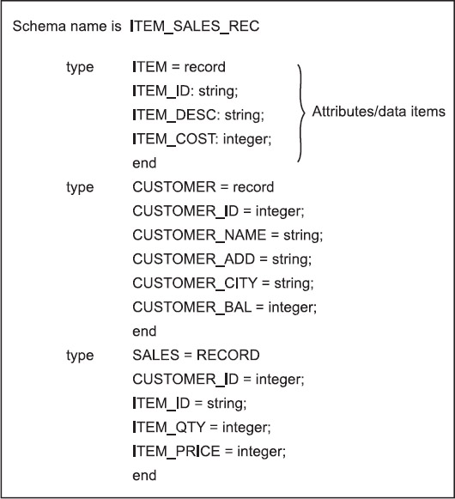
Generally, a schema can be partitioned into two categories, i.e., (i) Logical schema and (ii) Physical schema.
i) The logical schema is concerned with exploiting the data structures offered by the DBMS so that the schema becomes understandable to the computer. It is important as programs use it to construct applications.
ii) The physical schema is concerned with the manner in which the conceptual database get represented in the computer as a stored database. It is hidden behind the logical schema and can usually be modified without affecting the application programs.
Subschema : A subschema is a subset of the schema having the same properties that a schema has. It identifies a subset of areas, sets, records, and data names defined in the database schema available to user sessions. The subschema allows the user to view only that part of the database that is of interest to him. The subschema defines the portion of the database as seen by the application programs and the application programs can have different view of data stored in the database.
The different application programs can change their respective subschema without affecting other's subschema or view.
Instances: The data in the database at a particular moment of time is called an instance or a database state. In a given instance, each schema construct has its own current set of instances. Many instances or database states can be constructed to correspond to a particular database schema. Everytime we update (i.e., insert, delete or modify) the value of a data item in a record, one state of the database changes into another state.
Structure of Relational Database
The relational database structure was first invented in the 1970s as a response to increasing issues with flat files and the increasing complexity of data. The structure separates data about an object into a table and then links to related data tables using reference keys.

Tables: A relational database is a collection of related data tables. A data table is like a very structured Excel table. Columns describe the specific pieces of information in the table and each row stores the corresponding data. For example a "Customer" table may contain three columns: "CustomerID", "Lastname" and "FirstName" The table would then have customer data stored in the rows of the table.
Table 1. Database hierarchy
Component | Description
Data dictionary | A repository of information about the application programs, databases, logical data models, and authorizations for an organization.  When you change the data dictionary, the change process includes edit checks that can prevent the data dictionary from being corrupted. The only way to recover a data dictionary is to restore it from a backup.
Table | A database object that holds a collection of data for a specific topic. Tables consist of rows and columns.
Column | The vertical component of a database table. A column has a name and a particular data type for example, character, decimal, or integer.
Row | The horizontal component of a table, consisting of a sequence of values, one for each column of the table.
View | A logical table that is based on data stored in an underlying set of tables. The data returned by a view is determined by a SELECT statement that is run on the underlying tables.
Relationship | A link between one or more objects that is created by specifying a join statement.
Join | An SQL relational operation in which data can be retrieved from two tables, typically based on a join condition specifying join columns.

Keys in Database
Super Key: A combination of one or more columns in a table which can be used to identify a record in a table uniquely, a table can have any number of super keys. A candidate key is a closely related concept where the superkey is reduced to the minimum number of columns required to uniquely identify each row.
For example, imagine a table used to store customer master details that contains columns such as:
customer name, customer id, social security number (SSN), address, date of birth
A certain set of columns may be extracted and guaranteed unique to each customer. Examples of superkeys are as follows:
- Name+SSN+Birthdate
- ID+Name+SSN
However, this process may be further reduced. It can be assumed that each customer id is unique to each customer. So, the superkey may be reduced to just one field, customer id, which is the candidate key. However, to ensure absolute uniqueness, a composite candidate key may be formed by combining customer id with SSN.
Candidate Key: A Column (or) Combination of columns which can help uniquely identify a record in a table without the need of any external data is called a Candidate Key. Depending on the need and situation a Table may have one or more candidate keys and one of them can be used as a Primary Key of the table. A candidate key is a sub set of a Super Keys.
For Example, In an Employee Table, we may have columns like Employee ID, Employee Name, and Employee SSN. We can consider either Employee ID or Employee SSN as Candidate Key’s
Compound Key: A Combination of more than one column identifying records of a table uniquely, all the columns that take part in the combination process are Simple Key’s.
We can represent this buy taking a table which has the combined information of Department to Employees, Employee ID + Department ID – here both of them define a record in this table, but both can make sense separately as well.
Primary Key: A Column in a table which is a Candidate Key (Uniquely identify a records in a table) and has the Constraint NOT NULL attached to it is known as a Primary Key. A primary key is a single field or combination of fields that uniquely defines a record. A table can have only one primary key.In Oracle, a primary key can not contain more than 32 columns. A primary key can be defined in either a CREATE TABLE statement or an ALTER TABLE statement.
Composite Primary Key (Composite Key): When we have a Primary Key of a table defined using more than one columns then it is known as a Composite Key, each columns data can be duplicated, but combined values cannot be. The columns which are participating in a composite primary key are not simple keys.
For Example, we can have a situation where there is a need to define the key using first Name + last Name.
Alternate Key: We cannot define the Alternate Key Seperately from a Candidate Key, for a table, if there are two Candidate Key’s and one is chosen as a Primary Key the other Candidate Key is known as the Alternate Key of that table.
In Example, we can consider the Employee SSN as Alternate Key as we have taken Employee ID as our Primary Key
Unique Key: A column (or) combination of columns which can be used to uniquely identify a record in a table, it can have one NULL Value. Primary Key can be considered a special case of unique key with a Not Null Constraint.
Foreign Key: A column of one table points to the Primary Key column of another table to implement referential data integrity.
For Example, we can have a department id column in the employee table which is pointing to department id column in a department table where it a primary key.
CREATE TABLE Orders ( O_Id int NOT NULL PRIMARY KEY, OrderNo int NOT NULL, P_Id int FOREIGN KEY REFERENCES Persons(P_Id) );

ER Model
The first step in the database design process is to identify the organisations data requirements. Once the data requirements have been identified, the next step is to model the data as a conceptual schema for the database. The Entity Relationship Model (ERM) was first described by Chen in 1976, and is widely accepted as the standard for conceptual data modelling in the relational database environment. The ERM is a detailed, logical representation of the entities, associations and data elements for an organisation.
The Entity Relationship Diagram (ERD) is a graphical representation of an ERM and is currently one of the most popular and widely used database design tools.
Components of the ER Model: The three main components of the ER Model are entities, attributes and relationships.
In ERM terms, an entity is a "thing" within the organisation, that we want to keep information about, such as a customer, employee or course. In other words, an entity in an ERM actually refers to a table, and rows within the table are referred to as entity occurrences.Entities are represented by rectangles containing the name of the entity. Entity names must be singular and in capital letters.
Each entity has attributes which are the properties of each entity. Attributes will be implemented as columns in the tables. Each attribute has a domain which specifies the set of possible values an attribute can have. For instance, the range of values for a telephone extension may be specified as a set of integer numbers between 4000 and 4999. An attributes domain is not displayed in ER diagrams, but is recorded in the data dictionary.Attributes are represented by ovals with lines connecting them to the entity.
A relationship is the association between entities or entity occurrences. For example, a Teacher teaches Subjects or a Subject has Offerings. Relationships are represented by diamonds with straight lines connecting the participating entities.
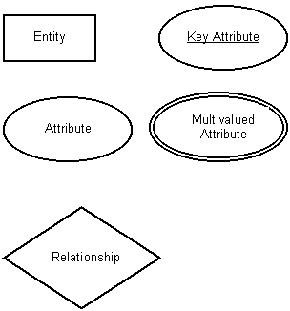

Types of Entity
Strong Entity: An entity can be a person, place, event, or object that is relevant to a given system. For example, a school system may include students, teachers, major courses, subjects, fees, and other items. Entities are represented in ER diagrams by a rectangle and named using singular nouns.

Weak Entity: There exists some entity type for which key attribute can’t be defined. These are called Weak Entity type.The entity sets which do not have sufficient attributes to form a primary key are known as weak entity sets and the entity sets which have a primary key are known as strong entity sets.
As the weak entities do not have any primary key, they cannot be identified on their own, so they depend on some other entity (known as owner entity). The weak entities have total participation constraint (existence dependency) in its identifying relationship with owner identity. Weak entity types have partial keys. Partial Keys are set of attributes with the help of which the tuples of the weak entities can be distinguished and identified.Weak entity is represented by double rectangle. The relation between one strong and one weak entity is represented by double diamond.
In the below ER Diagram, ‘Payment’ is the weak entity. ‘Loan Payment’ is the identifying relationship and ‘Payment Number’ is the partial key. Primary Key of the Loan along with the partial key would be used to identify the records.
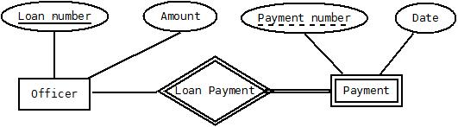

Types of Attributes:
- Simple attribute − Simple attributes are atomic values, which cannot be divided further. For example, a student's phone number is an atomic value of 10 digits.
- Composite attribute − Composite attributes are made of more than one simple attribute. For example, a student's complete name may have first_name and last_name.
- Derived attribute − Derived attributes are the attributes that do not exist in the physical database, but their values are derived from other attributes present in the database. For example, average_salary in a department should not be saved directly in the database, instead it can be derived. For another example, age can be derived from data_of_birth.
- Single-value attribute − Single-value attributes contain single value. For example − Social_Security_Number.
- Multi-value attribute − Multi-value attributes may contain more than one values. For example, a person can have more than one phone number, email_address, etc.

Degree of Relationship
The number of participating entities in a relationship defines the degree of the relationship. A relationship degree indicates the number of entities or participants associated with a relationship. A ternary relationship exists when three entities are associated. Although higher degrees exist, they are rare and are not specifically named. (For example, an association of four entities is described simply as a four-degree relationship.)
- Unary Relationships: A unary relationship exists when an association is maintained within a single entity.
In the case of the unary relationship shown in the following Figure an employee within the EMPLOYEE entity is the manager for one or more employees within that entity. In this case, the existence of the “manages” relationship means that EMPLOYEE requires another EMPLOYEE to be the manager—that is, EMPLOYEE has a relationship with itself. Such a relationship is known as a recursive relationship.
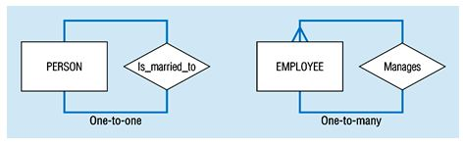
- Binary Relationships: A binary relationship exists when two entities are associated. A binary relationship exists when two entities are associated in a relationship. Binary relationships are most common. For example the relationship “a PROFESSOR teaches one or more CLASS” represents a binary relationship.
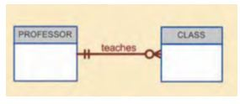
- Ternary Relationships: A ternary relationship exists when exactly three entity types participate. When such a relationship is present we say that the degree is 3. As the number of entity increases in the relationship, it becomes complex to convert them into relational tables.
For example, we have three entity type ‘Employee’, ‘Department’ and ‘Location’. The relationship between these entities is defined as an employee works in a department, an employee works at a particular location. So, we can see we have three entities participating in a relationship so it is a ternary relationship. The degree of this relation is 3.
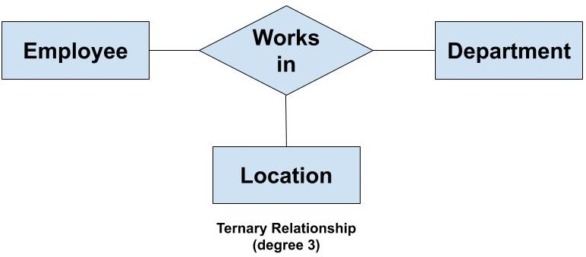
N-ary (n degree) : An N-ary relationship exists when ‘n’ number of entities are participating. So, any number of entities can participate in a relationship. There is no limitation to the maximum number of entities that can participate. But, relations with a higher degree are not common. This is because the conversion of higher degree relations to relational tables gets complex
We represent an N-ary relationship as follows:
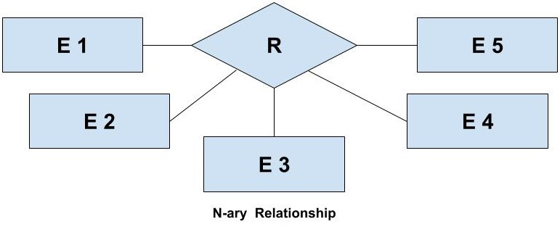

Mapping Cardinalities: Cardinality defines the number of entities in one entity set, which can be associated with the number of entities of other set via relationship set.
- One-to-one − One entity from entity set A can be associated with at most one entity of entity set B and vice versa.
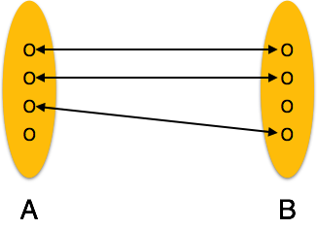

- One-to-many − One entity from entity set A can be associated with more than one entities of entity set B however an entity from entity set B, can be associated with at most one entity.
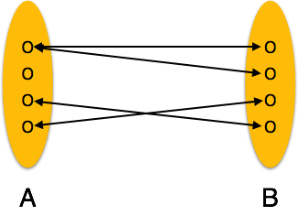
- Many-to-one − More than one entities from entity set A can be associated with at most one entity of entity set B, however an entity from entity set B can be associated with more than one entity from entity set A.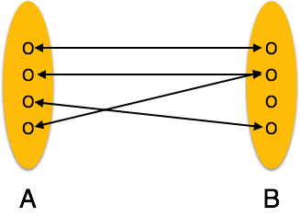
- Many-to-many − One entity from A can be associated with more than one entity from B and vice versa.
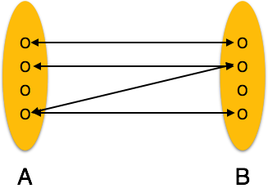

Enhanced ER Model (EER): Today’s time the complexity of the data is increasing so it becomes more and more difficult to use the traditional ER model for database modeling. To reduce this complexity of modeling we have to make improvements or enhancements in the existing ER model to make it able to handle the complex application in a better way. It is a diagrammatic technique for displaying the Sub Class and Super Class; Specialization and Generalization; Union or Category; Aggregation etc.

Generalization: Generalization is a bottom-up approach in which two lower level entities combine to form a higher level entity. In generalization, the higher level entity can also combine with other lower level entities to make further higher level entity.It's more like Superclass and Subclass system, but the only difference is the approach, which is bottom-up. Hence, entities are combined to form a more generalised entity, in other words, sub-classes are combined to form a super-class.
For example, Saving and Current account types entities can be generalised and an entity with name Account , which covers both.
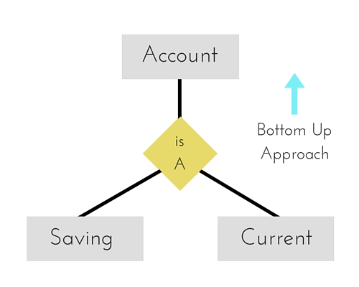

Specialization: Specialization is opposite to Generalization. It is a top-down approach in which one higher level entity can be broken down into two lower level entity. In specialization, a higher level entity may not have any lower-level entity sets, it's possible.
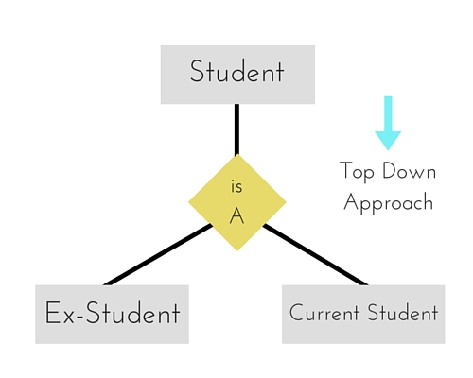
Aggregation: Aggregation is a process when relation between two entities is treated as a single entity. In the diagram above, the relationship between Center and Course together, is acting as an Entity, which is in relationship with another entity Visitor. Now in real world, if a Visitor or a Student visits a Coaching Center, he/she will never enquire about the center only or just about the course, rather he/she will ask enquire about both.
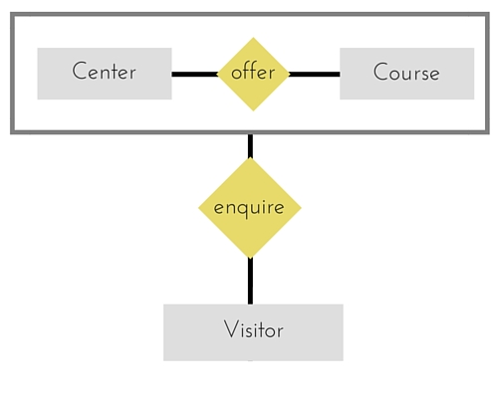
Enhanced ER model of above example –
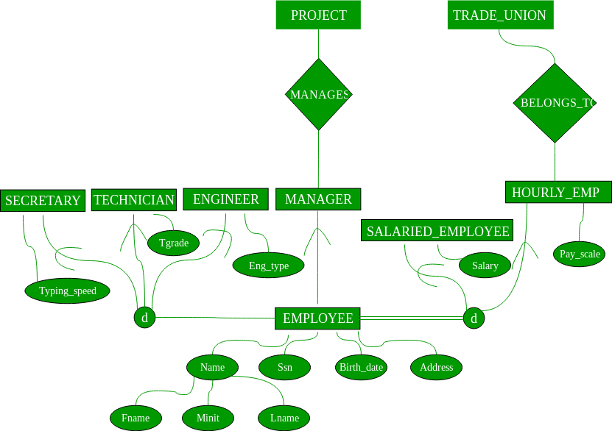

Constraints – There are two types of constraints on “Sub-class” relationship.

Total Participation-

- It specifies that each entity in the entity set must compulsorily participate in at least one relationship instance in that relationship set.
- That is why; it is also called as mandatory participation.
- Total participation is represented using a double line between the entity set and relationship set.

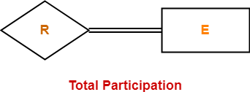

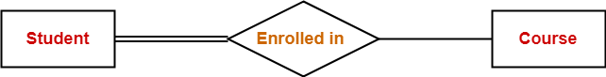

Here,
- Double line between the entity set “Student” and relationship set “Enrolled in” signifies total participation.
- It specifies that each student must be enrolled in at least one course.

Partial Participation-

- It specifies that each entity in the entity set may or may not participate in the relationship instance in that relationship set.
- That is why, it is also called as optional participation.
- Partial participation is represented using a single line between the entity set and relationship set.

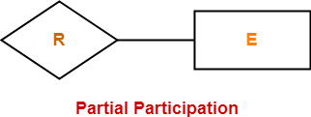
Here,
- Single line between the entity set “Course” and relationship set “Enrolled in” signifies partial participation.
- It specifies that there might exist some courses for which no enrollments are made.

Disjoint constraints: The disjoint constraint only applies when a superclass has more than one subclass. If the subclasses are disjoint, then an entity occurrence can be a member of only one of the subclasses, e.g. A student can be enrolled in one course postgrads or undergrads cannot be both. To represent a disjoint superclass/subclass relationship, is used.
Student
UnderGrad
PostGrad
d

Overlap: This applies when an entity occurrence may be a member of more than one subclass, e.g. student and staff some people are both.
Student
UnderGrad
PostGrad
o

Relational Database Design by ER- and EER-to-Relational Mapping: The ER schema diagram for the COMPANY database.

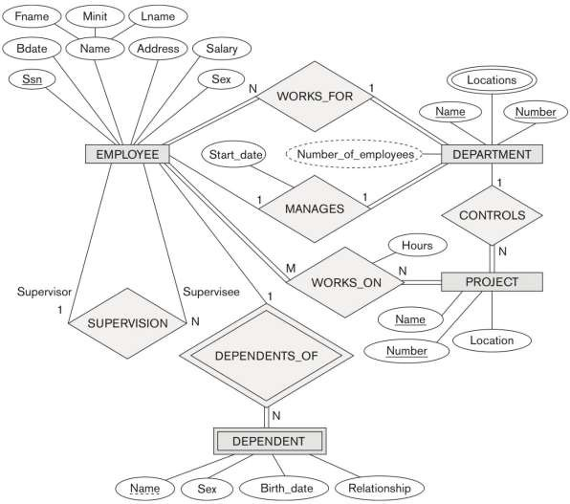

ER-to-Relational Mapping Algorithm

Step 1: Mapping of Regular Entity Types.
  - For each regular (strong) entity type E in the ER schema, create a relation R that includes all the simple attributes of E.
  - Choose one of the key attributes of E as the primary key for
R.
  - If the chosen key of E is composite, the set of simple attributes that form it will together form the primary key of R.
- Example: We create the relations EMPLOYEE, DEPARTMENT, and PROJECT in the relational schema corresponding to the regular entities in the ER diagram.
  - SSN, DNUMBER, and PNUMBER are the primary keys for the relations EMPLOYEE, DEPARTMENT, and PROJECT as shown.
- Step 2: Mapping of Weak Entity Types
  - For each weak entity type W in the ER schema with owner entity type E, create a relation R & include all simple attributes (or simple components of composite attributes) of W as attributes of R.
  - Also, include as foreign key attributes of R the primary key attribute(s) of the relation(s) that correspond to the owner entity type(s).
  - The primary key of R is the combination of the primary key(s) of
the owner(s) and the partial key of the weak entity type W, if any.

Example: Create the relation DEPENDENT in this step to correspond to the weak entity type DEPENDENT.
  - Include the primary key SSN of the EMPLOYEE relation as a
foreign key attribute of DEPENDENT (renamed to ESSN).
  - The primary key of the DEPENDENT relation is the combination
{ESSN, DEPENDENT_NAME} because DEPENDENT_NAME is the partial key of DEPENDENT.
- Step 3: Mapping of Binary 1:1 Relation Types
  - For each binary 1:1 relationship type R in the ER schema, identify the relations S and T that correspond to the entity types participating in R.

Foreign Key (2 relations) approach: Choose one of the relations-say S-and include a foreign key in S the primary key of T. It is better to choose an entity type with total participation in R in the role of S.
  - Example: 1:1 relation MANAGES is mapped by choosing the participating entity type DEPARTMENT to serve in the role of S, because its participation in the MANAGES relationship type is total.

Step 4: Mapping of Binary 1:N Relationship Types.
  - For each regular binary 1:N relationship type R, identify the relation S that represent the participating entity type at the N-side of the relationship type.
  - Include as foreign key in S the primary key of the relation T that represents the other entity type participating in R.
  - Include any simple attributes of the 1:N relation type as attributes of S.
- Example: 1:N relationship types WORKS_FOR, CONTROLS, and SUPERVISION in the figure.
  - For WORKS_FOR we include the primary key DNUMBER of the DEPARTMENT relation as foreign key in the EMPLOYEE relation and call it DNO.
  - Step 5: Mapping of Binary M:N Relationship Types.
    - For each regular binary M:N relationship type R, create a new relation S to represent R. This is a relationship relation.
    - Include as foreign key attributes in S the primary keys of the relations that represent the participating entity types; their combination will form the primary key of S.
    - Also include any simple attributes of the M:N relationship type (or simple components of composite attributes) as attributes of S.

Example: The M:N relationship type WORKS_ON from the ER diagram is mapped by creating a relation WORKS_ON in the relational database schema.
    - The primary keys of the PROJECT and EMPLOYEE relations are included as foreign keys in WORKS_ON and renamed PNO and ESSN, respectively.
    - Attribute HOURS in WORKS_ON represents the HOURS attribute of the relation type. The primary key of the WORKS_ON relation is the combination of the foreign key attributes {ESSN, PNO}.

Step 6: Mapping of Multivalued attributes.
    - For each multivalued attribute A, create a new relation R.
    - This relation R will include an attribute corresponding to A, plus the primary key attribute K-as a foreign key in R-of the relation that represents the entity type of relationship type that has A as an attribute.
    - The primary key of R is the combination of A and K. If the multivalued attribute is composite, we include its simple components.

Example: The relation DEPT_LOCATIONS is created.
    - The attribute DLOCATION represents the multivalued attribute LOCATIONS of DEPARTMENT, while DNUMBER-as foreign key- represents the primary key of the DEPARTMENT relation.
    - The primary key of R is the combination of {DNUMBER, DLOCATION}.
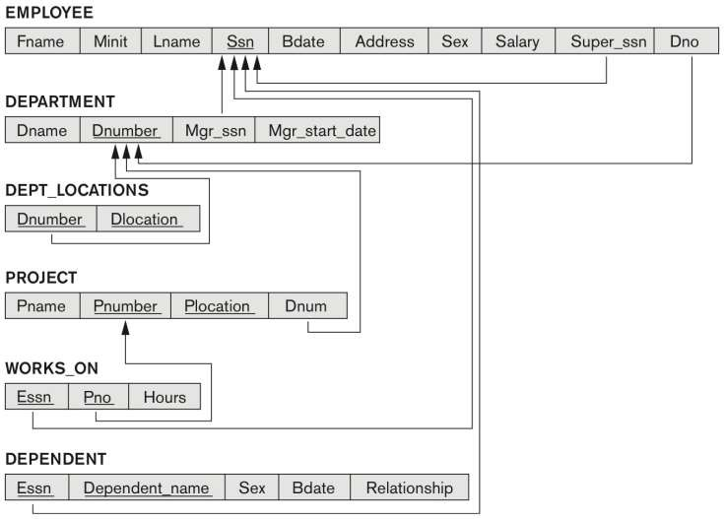
Figure 9.2 Result of mapping the COMPANY ER schema into a relational database schema.
Mapping of Generalization and Specialization Hierarchies to a Relational Schema
Options for Mapping Specialization or Generalization.
  - Convert each specialization with m subclasses {S1, S2,….,Sm} and generalized superclass C, where the attributes of C are {k,a1,…an} and k is the (primary) key, into relational schemas using one of the four following options:

A: Multiple relations-Superclass and subclasses
  - Create a relation L for C with attributes Attrs(L) = {k,a1,…an} and PK(L) = k. Create a relation Li for each subclass Si, 1 < i < m, with the attributesAttrs(Li) = {k} U {attributes of Si} and PK(Li)=k. This option works for any specialization (total or partial, disjoint of over-lapping).
B: Multiple relations-Subclass relations only
  - Create a relation Li for each subclass Si, 1 < i < m, with the
attributes Attr(Li) = {attributes of Si} U {k,a1…,an} and PK(Li) =
k. This option only works for a specialization whose subclasses are total (every entity in the superclass must belong to (at least) one of the subclasses).
C: Single relation with one type attribute
  - Create a single relation L with attributes Attrs(L) = {k,a1,…an} U
{attributes of S1} U…U {attributes of Sm} U {t} and PK(L) = k. The attribute t is called a type (or discriminating) attribute that
indicates the subclass to which each tuple belongs
D: Single relation with multiple type attributes
  - Create a single relation schema L with attributes Attrs(L) =
{k,a1,…an} U {attributes of S1} U…U {attributes of Sm} U {t1, t2,…,tm} and PK(L) = k. Each ti, 1 < I < m, is a Boolean type attribute indicating whether a tuple belongs to the subclass Si.
EER diagram notation for an attribute-defined specialization on JobType.
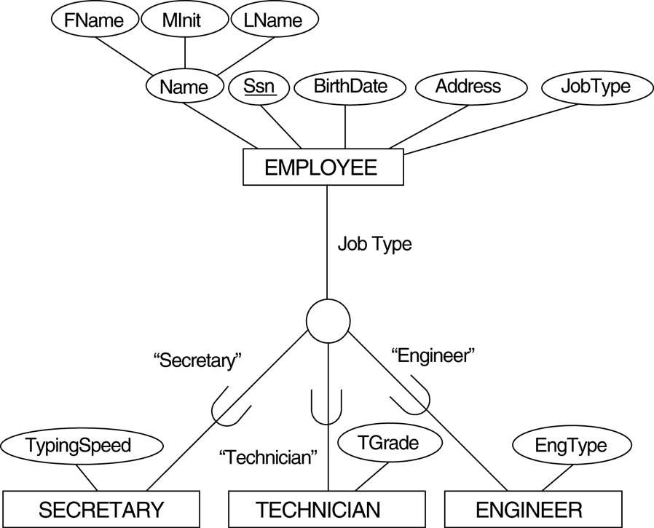

Mapping the EER schema using option A

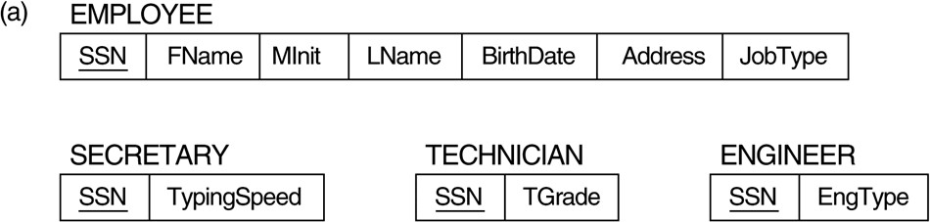
Mapping the EER schema using option C

Generalizing CAR and TRUCK into the superclass VEHICLE.

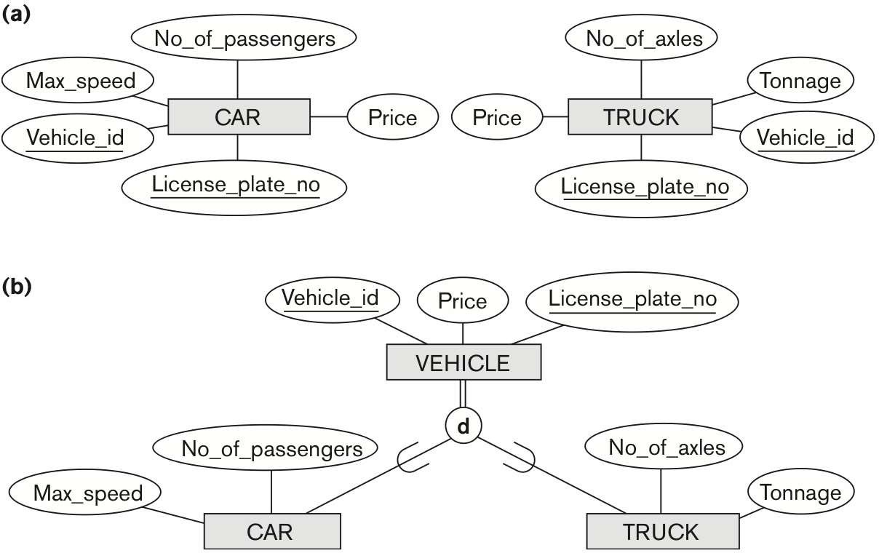
Mapping the EER schema using option B.
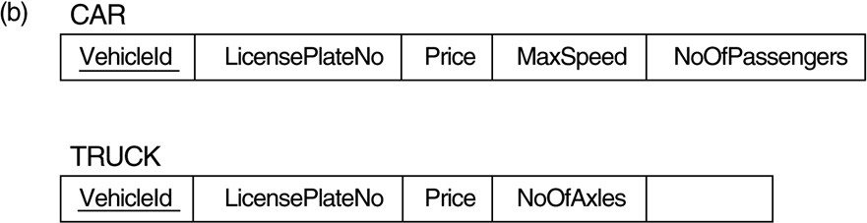

An overlapping (non-disjoint) specialization.
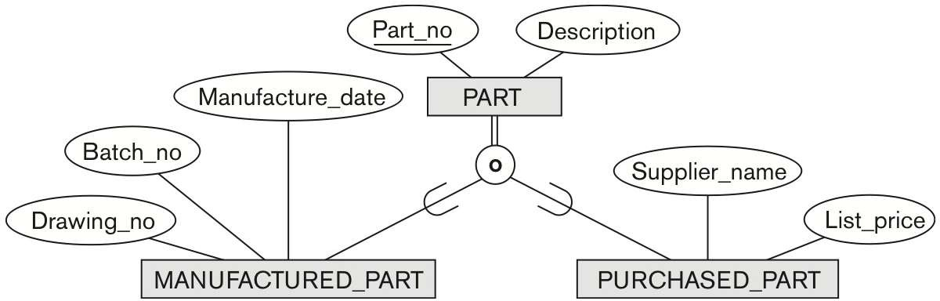

Mapping using option D with Boolean type fields Mflag and Pflag.

Fig. 9.5: Different Options for Mapping Generalization Hierarchies - summary

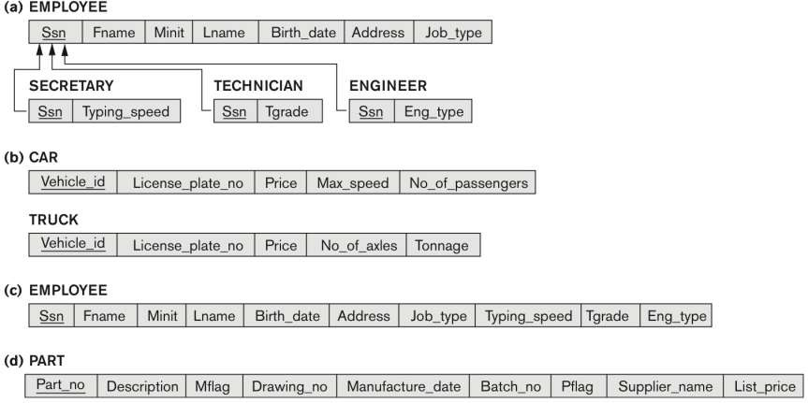
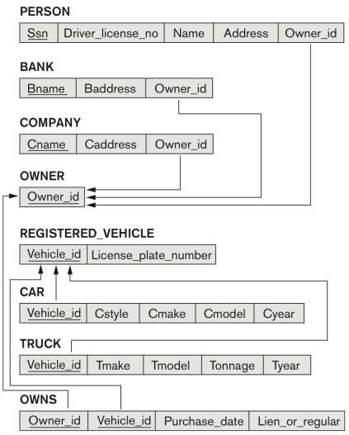
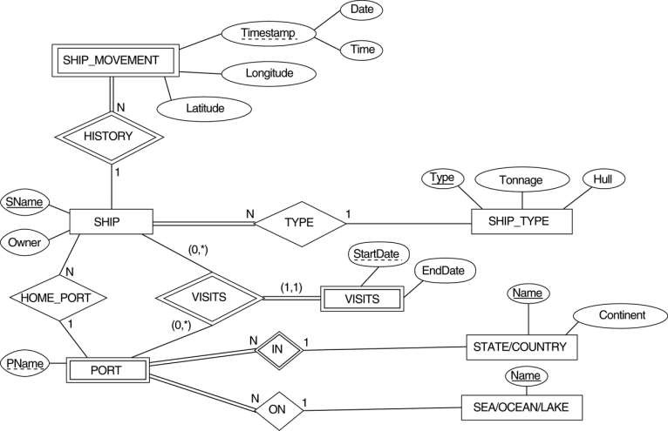
Mapping Exercise-An ER schema for a SHIP_TRACKING database.

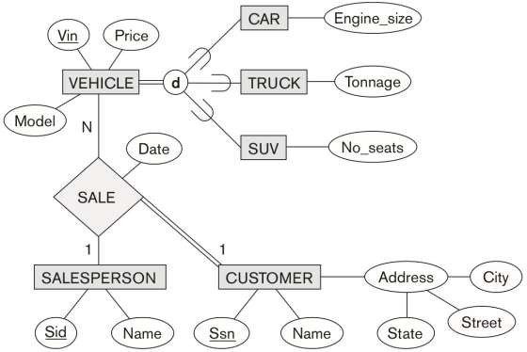
Mapping Exercise-2 EER diagram for a car dealer

